Observation 1:

Select b.exists_in_irisk_flag_c,Count(1)

FROM ldb.f_rita_application_c_fact a

JOIN ldb.d_rita_application_c b ON a.rita_application_c_key=b.row_key

group by 1;

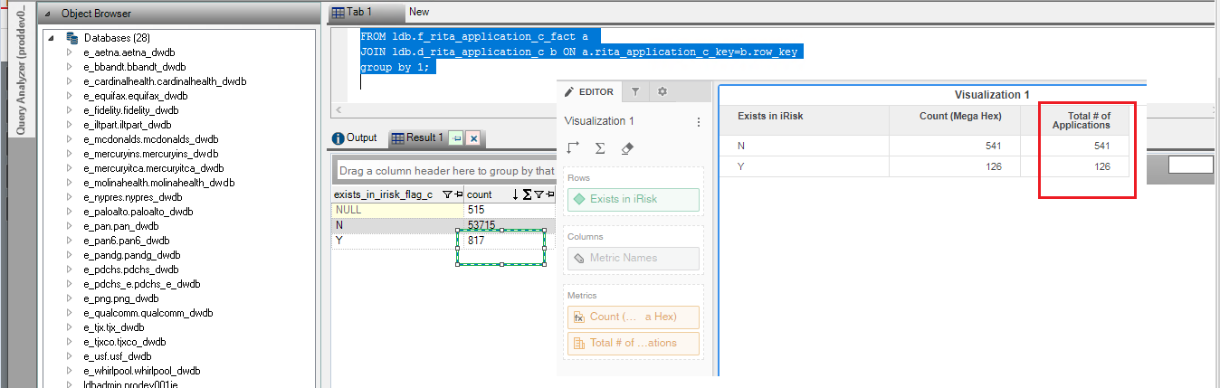

Observation 2:

Select b.exists_in_legacy_g1_c,Count(1)

FROM ldb.f_rita_application_c_fact a

JOIN ldb.d_rita_application_c b ON a.rita_application_c_key=b.row_key

Where a.soft_deleted_flag='N'

group by 1;

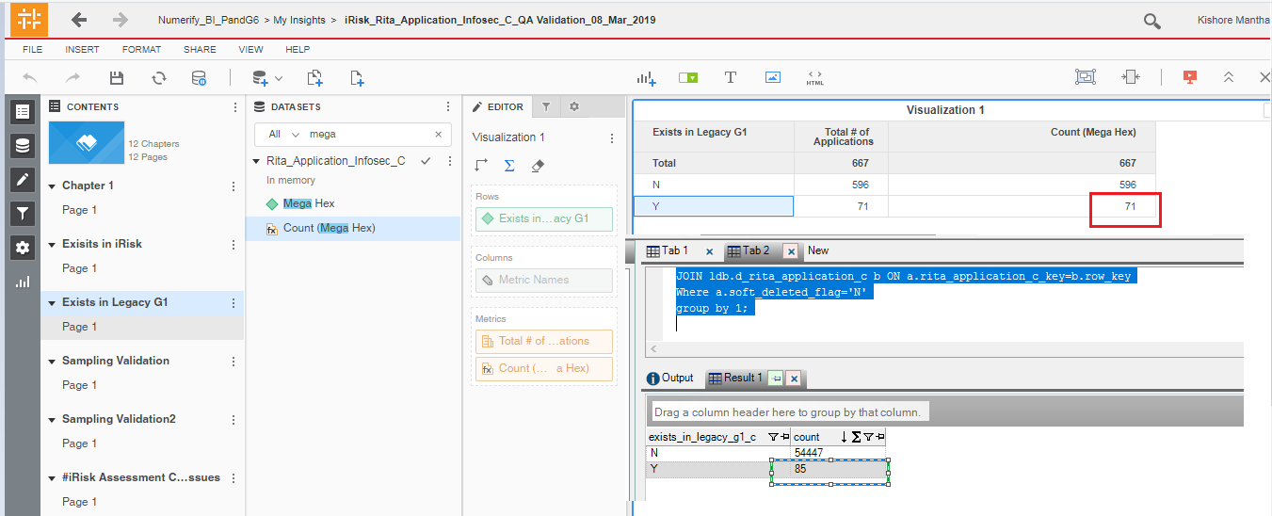

Observation 3:

Select b.exists_in_legacy_g234_c,

Count(1)

FROM ldb.f_rita_application_c_fact a

JOIN ldb.d_rita_application_c b ON a.rita_application_c_key=b.row_key

Where a.soft_deleted_flag='N'

group by 1;

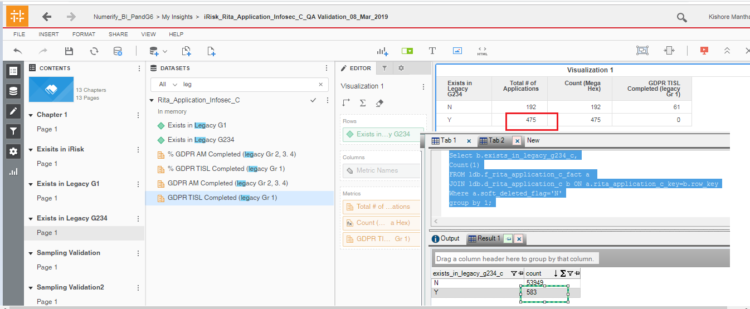

Observation 4:

Below Attributes should be added to ‘Rita_Application_Infosec_c’ cube.

Owning Organization

P&G Asset Owner

Application Lifecycle Status

Application Repository Type.

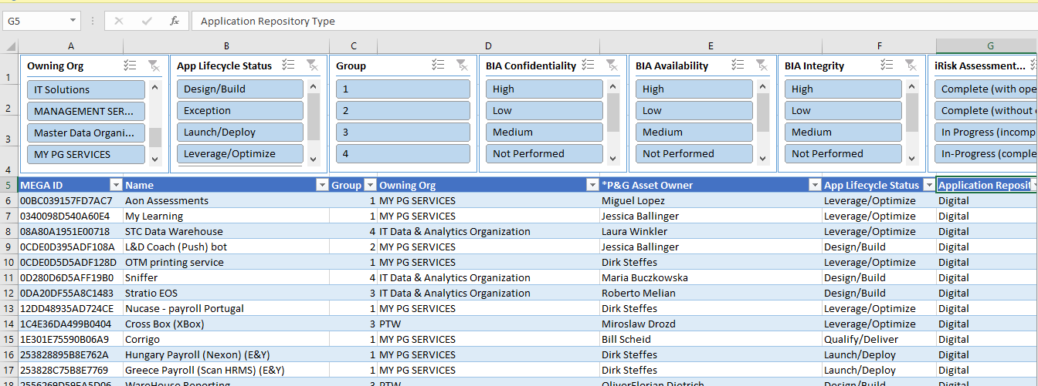

Observation 5:

SELECT SRC.PG_BIA_AVAILABILITY_RATING ,COALESCE(LKP.row_key,CASE WHEN SRC.PG_BIA_AVAILABILITY_RATING IS NULL THEN 0 ELSE -1 END),TRGT.pg_bia_availability_rating_c_key,

Count(1) as CNT

FROM

png_mdsdb.pg_mega_pgb_application_rita_final SRC

LEFT JOIN png_mdsdb.pg_mega_irisk_assessment_issues_final SRC1

ON SRC.NAME=SRC1.Mega_hex_id AND SRC.sourceinstance=SRC1.sourceinstance AND SRC1.cdctype<>'D'

LEFT JOIN png_mdwdb.d_lov LKP ON CONCAT('AVAILABILITY_RATING','~','MEGA_APPLICATION','~',SRC.PG_BIA_AVAILABILITY_RATING)=LKP.row_id AND

SRC.sourceinstance=LKP.source_id

LEFT JOIN png_mdwdb.d_rita_application_c TRGT ON SRC.NAME=TRGT.row_id AND SRC.sourceinstance=TRGT.source_id

WHERE SRC1.Mega_hex_id iS NOT NULL

AND SRC.cdctype<>'D'

group by 1;

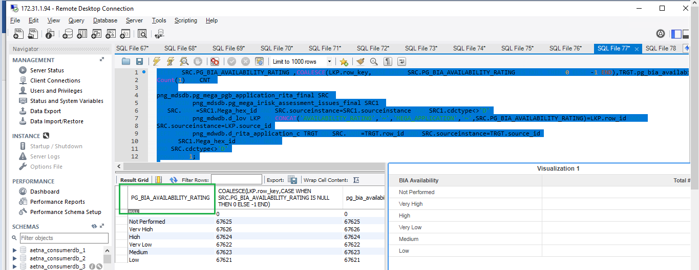

Observation 6:

SELECT SRC.PG_BIA_CONFIDENTIALITY_RATING,COALESCE(LKP.row_key,CASE WHEN SRC.PG_BIA_CONFIDENTIALITY_RATING IS NULL THEN 0 ELSE -1 END),TRGT.pg_bia_confidentiality_rating_c_key,Count(1) as CNT

FROM

png_mdsdb.pg_mega_pgb_application_rita_final SRC

LEFT JOIN png_mdwdb.d_lov LKP ON (CONCAT('CONFIDENTIALITY_RATING','~','MEGA_APPLICATION','~',SRC.PG_BIA_CONFIDENTIALITY_RATING)=LKP.row_id AND

SRC.sourceinstance=LKP.source_id)

LEFT JOIN png_mdwdb.d_rita_application_c TRGT ON SRC.NAME=TRGT.row_id AND SRC.sourceinstance=TRGT.source_id

WHERE SRC.cdctype<>'D'

group by 1;

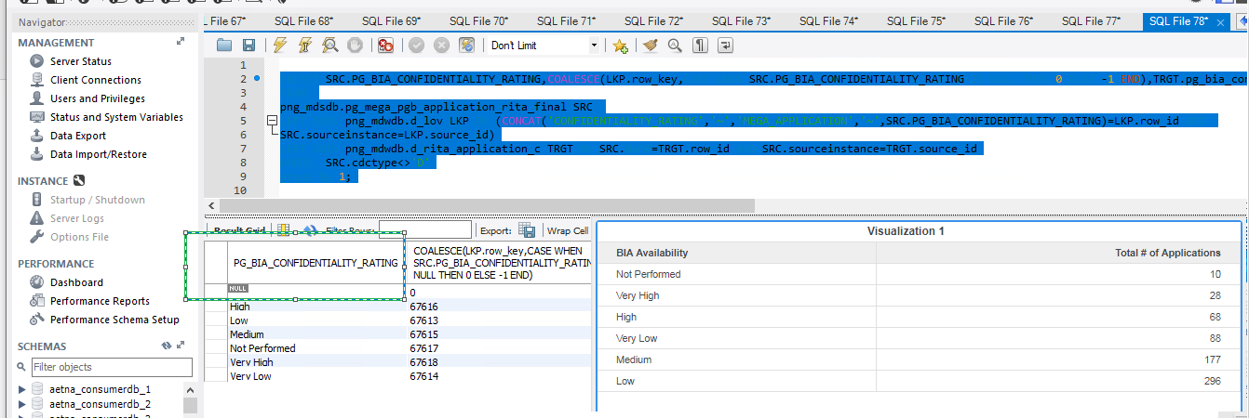

Observation 7:

